**NYC Restaurant Locator Web Application**

**PROJECT SUMMARY:** A restaurant is a [business](https://en.wikipedia.org/wiki/Business) which prepares and serves food and drinks to customers in exchange for money, either paid before the meal, after the meal or with an open account. Meals are generally served and eaten on premises, but many restaurants also offer [take-out](https://en.wikipedia.org/wiki/Take-out) and [food delivery services](https://en.wikipedia.org/wiki/Delivery_(commerce)). Restaurants vary greatly in appearance and offerings, including a wide variety of [cuisines](https://en.wikipedia.org/wiki/Cuisine) and [service](https://en.wikipedia.org/wiki/Customer_service) models ranging from inexpensive [fast food](https://en.wikipedia.org/wiki/Fast_food) restaurants to high-priced luxury establishments. In Western countries, most mid- to high-range restaurants serve alcoholic beverages such as beer and wine. Some restaurants serve all the major meals, such as [breakfast](https://en.wikipedia.org/wiki/Breakfast), [lunch](https://en.wikipedia.org/wiki/Lunch) and [dinner](https://en.wikipedia.org/wiki/Dinner) (e.g., major fast food chains, hotel restaurants and airport restaurants). Other restaurants may only serve a single meal (e.g., a [pancake house](https://en.wikipedia.org/wiki/Pancake_house) may only serve breakfast) or they may serve two meals (e.g., lunch and dinner). The main goal of this project is to guide the user in locating and visualizing the Restaurants location in Google maps in the New York City and get the directions to the selected restaurant using Google maps. The application also provides the user to create, update, view and delete the locations.

**E-R DESIGN:** The following diagram describes the E-R Design of our system

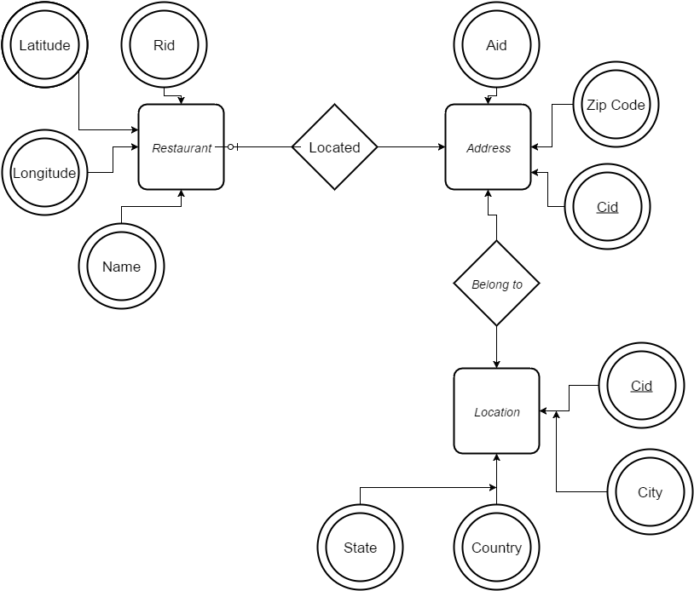

**RELATIONAL DATABASE SCHEMA:**

**Restaurant** (rid, Longitude, Latitude, Phone, aid)

**Address**(aid, Zipcode, cid) cid attribute is the foreign key with the cid attribute of Location Entity Set

**Location** (cid, City, State, Country)

**Located**(sid, aid)

**BelongTo**(aid, cid)

**PROJECT ENVIRONMENT:**PROGRAMMING LANGUAGE: NET( C#, Asp.NET) USING VISUAL STUDIO 2012DATABASE: MICROSOFT SQL SERVER 2005

**DATASET:** The application requires data about NYC Restaurants locations. We collected the data from the NYC Open Data Portal and performed Data Cleaning process so as to load the data into the database in the correct format.

We collected Data from- <http://milesgrimshaw.com/nyc-restaurant-database/> which was having nearly 26k records which are geocoded.

Functionalities: The basic functionalities of this project are to insert, update, delete and view the restaurants data present in the database. Each functionality can be explained as below.

**Insert Data:**



This functionality simply takes the name, street, and zip code from the user assuming that the state and city are NY. After the user enters the data correctly the geocoded data is inserted into the database.

**Edit Data:**

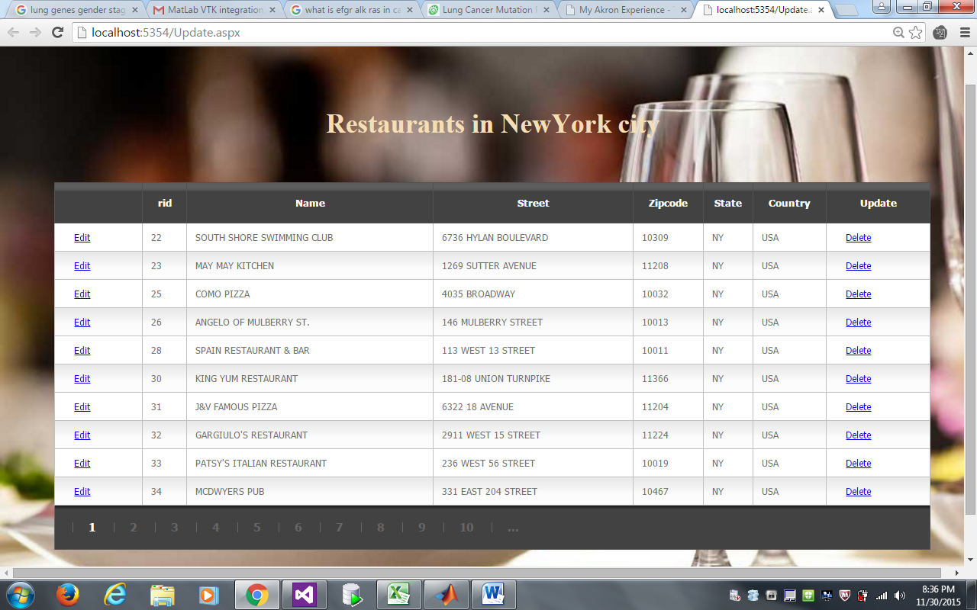

This functionality allows the user to update and delete the records present in the database. The user can update the restaurant name, street and zip code details of the restaurant. The user can delete the restaurant data present in the database after asking for a confirmation which can be seen in the below screenshot. The update functionality can be seen in the below pages.

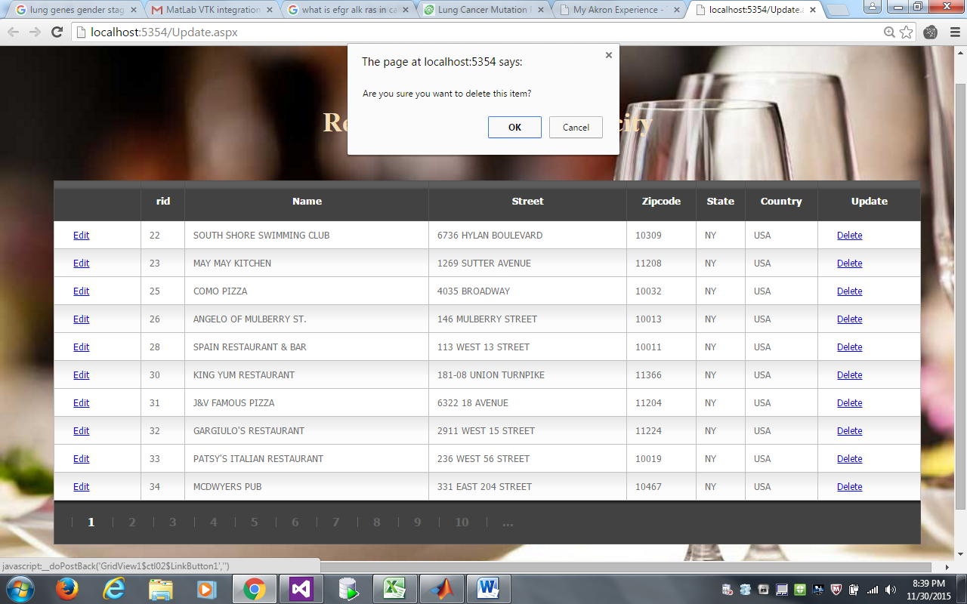

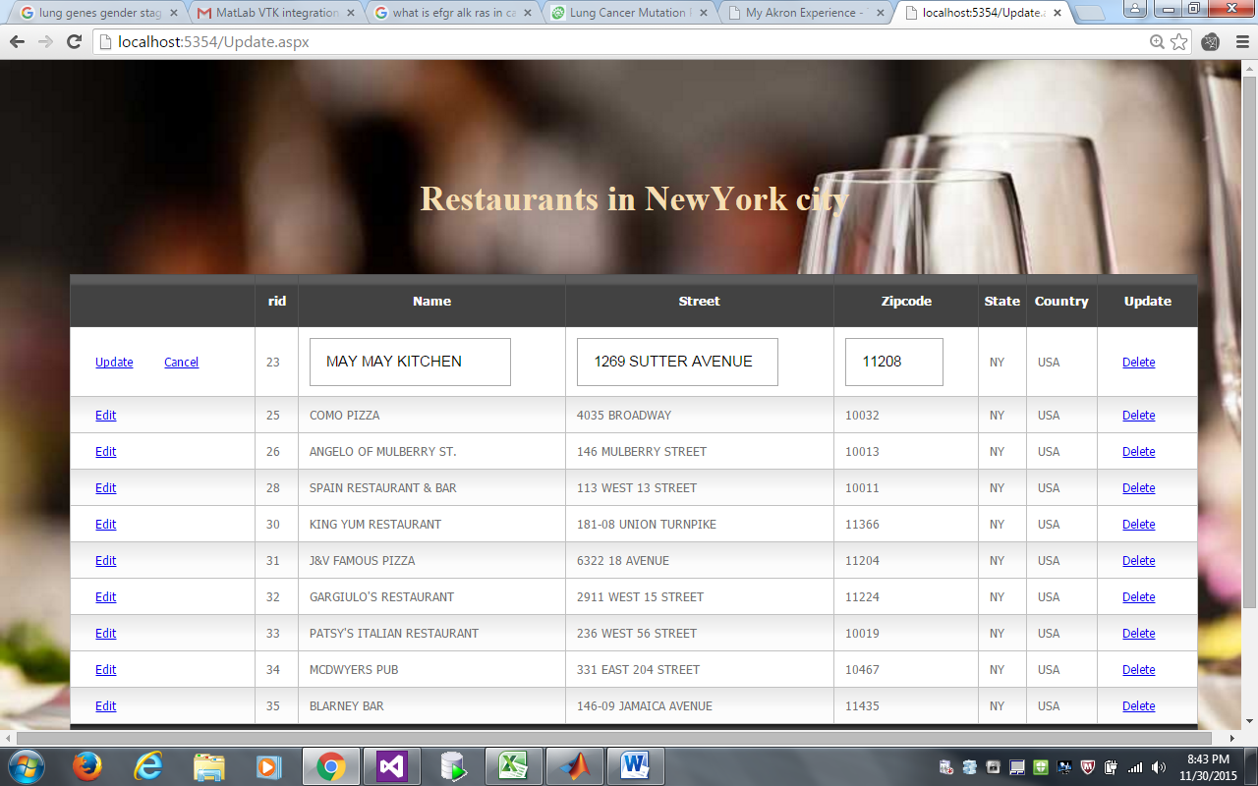

**View Data:**

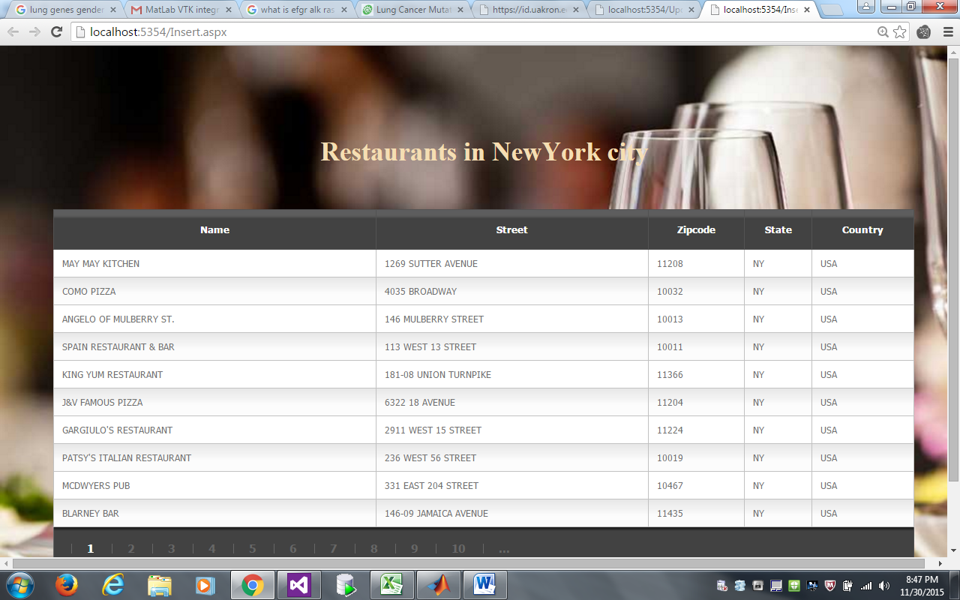

This functionality allows the user to view all the restaurant data present in the database. Our Database contains nearly 30k records.

**Search:** This functionality allows the user to search for a particular restaurant within the database, For example if the user wants to search all the subways present in the new York city that can be achieved using this functionality, All the functionalities can be explained by the screenshots below.

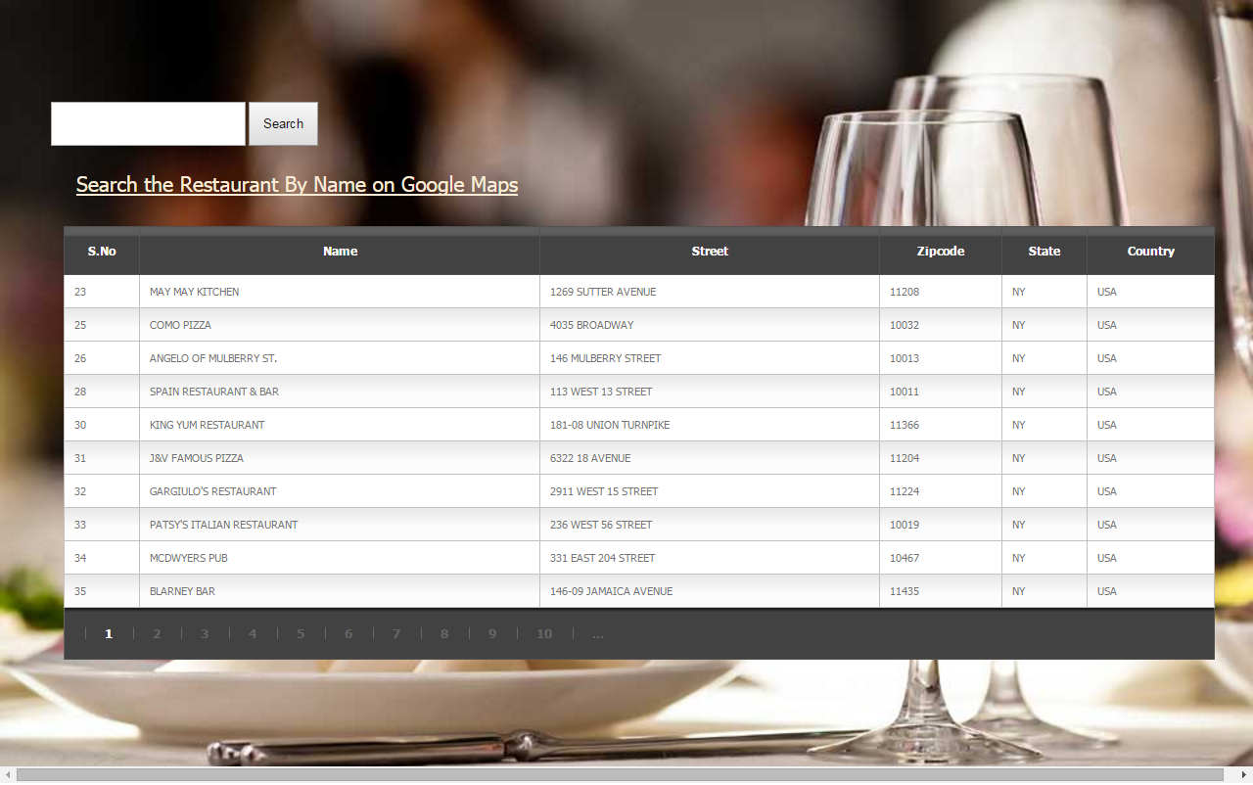

This page contains a text box where the user can enter the keyword by which the results are filtered and displayed accordingly. By Default, all the results will be displayed within the database.

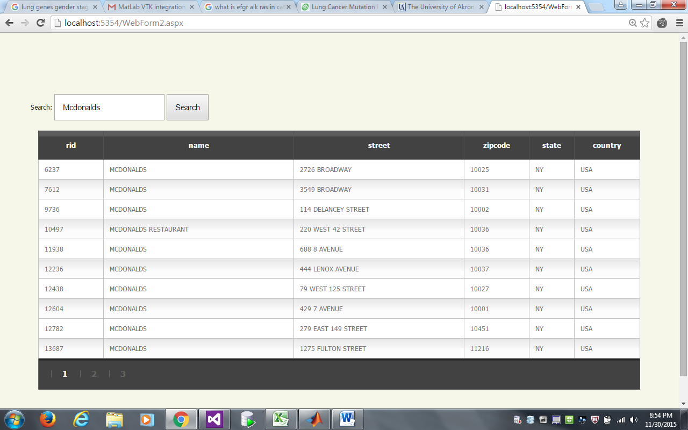

If the user searches for a string “Mc Donald’s”, then the results are displayed as shown.

**Advanced Functionalities:**

**Search and located on Map:**

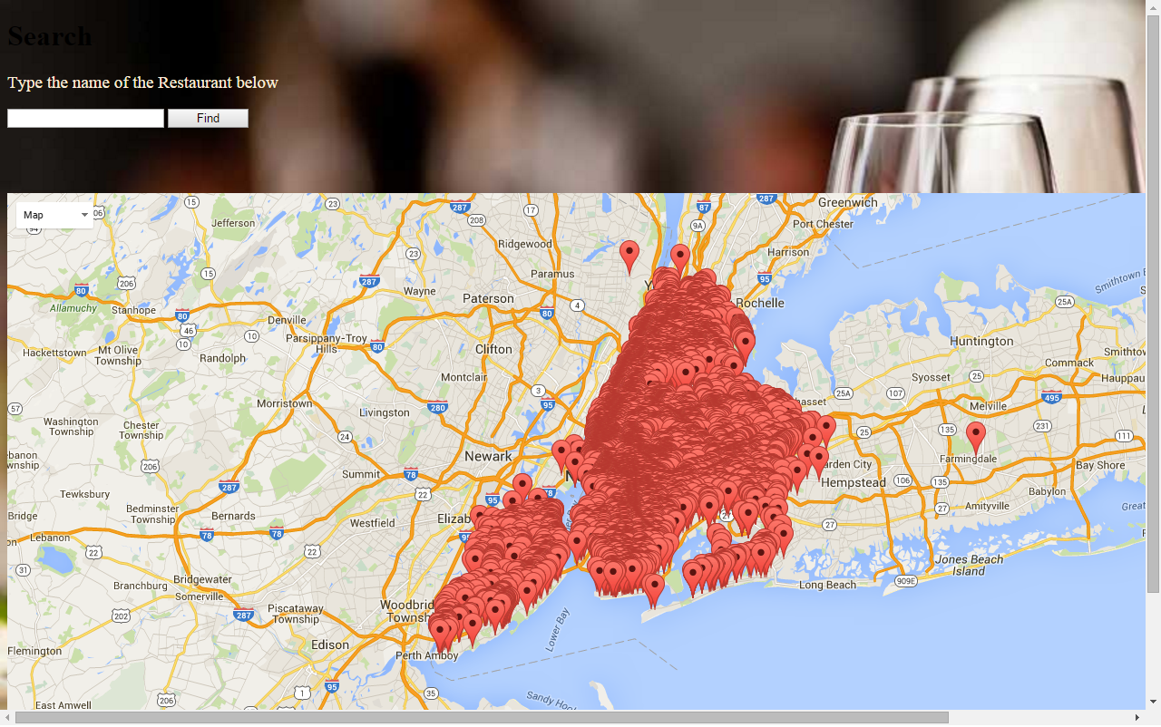

This functionality allows the user to search for a particular restaurant and locate it on the map. By default, all the restaurants within the database are displayed on a map. When the user enters the search string and clicks on find all the restaurants related to the search string are displayed on a map.

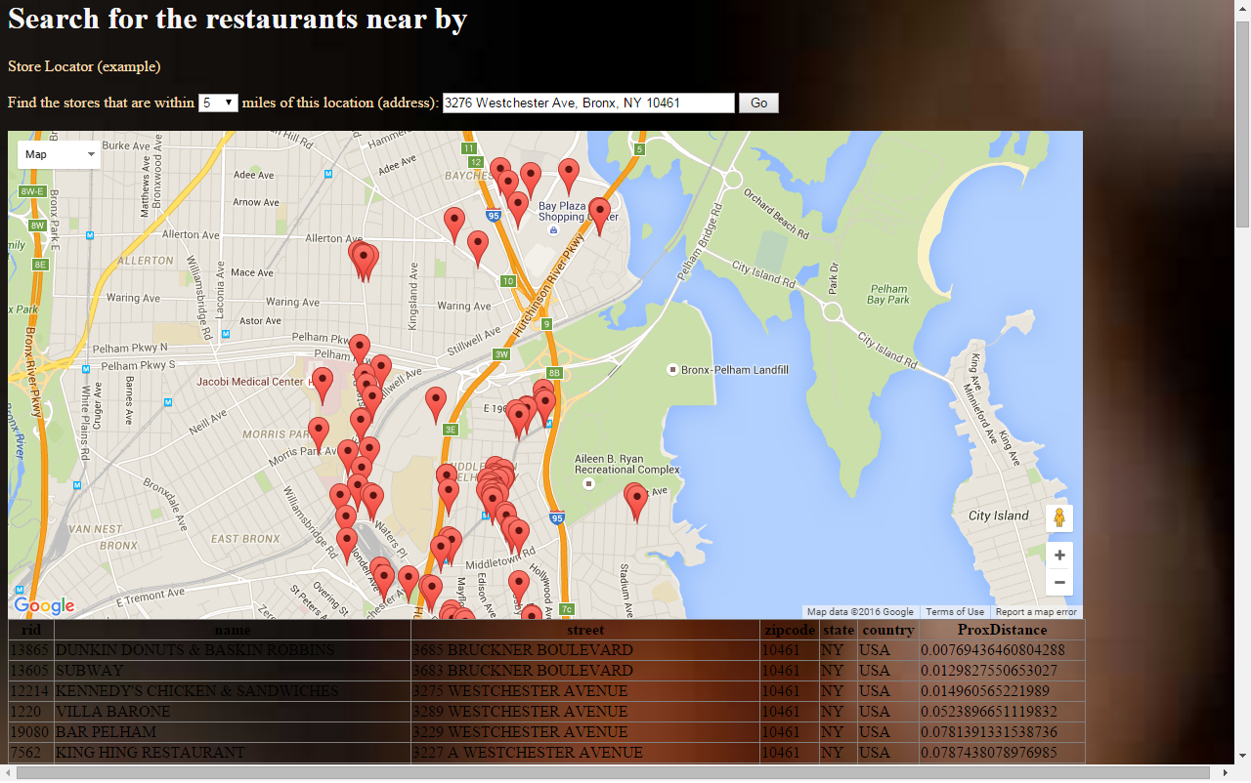

This figure shows the user all the restaurants matched with the string searched on map.

The Advanced functionality which we plan to develop is to search for all the restaurants within a particular range. This functionality has been completed but needs to be refined for rich UI and to display distance in miles.